Week-1:-

Google Cybersecurity Certificate overview
Hello, and welcome to the Google Cybersecurity Certificate! In this program, you will explore the growing field of cybersecurity, learn how cybersecurity is crucial to organizations and the people they serve, and develop relevant skills for a future career in the field. By completing the eight courses in this certificate program, you'll prepare for entry-level jobs in cybersecurity, such as cybersecurity analyst, security analyst, and security operations center (SOC) analyst. No prior experience in cybersecurity is required to complete this program.

Enter a growing field
Why are skills in cybersecurity in such high demand? The world is undergoing a digital transformation. Every day, global access to the internet is expanding, introducing more devices, more applications, and an even larger amount of data to the World Wide Web. As a result, threats, risks, and vulnerabilities are expanding and causing a significant amount of harm to organizations and people. Cybersecurity professionals are in high demand to help keep organizations, people, and data safe.
Throughout the program, you will have multiple opportunities to develop your cybersecurity knowledge and skills. You will explore concepts and scenarios to learn what an entry-level cybersecurity analyst must know and be able to do to thrive in the cybersecurity profession.

Google Cybersecurity Certificate courses
The Google Cybersecurity Certificate has eight courses that focus and build upon core concepts and skills related to the daily work of cybersecurity professionals, including foundational cybersecurity models and frameworks that are used to mitigate risk; protecting networks and data; using programming to automate tasks; identifying and responding to security incidents; and communicating and collaborating with stakeholders. Additionally, you will apply what you’ve learned in each course by completing portfolio projects that can be used to showcase your understanding of essential cybersecurity concepts to potential employers.
The courses of the program are as follows:
- Foundations of Cybersecurity (current course)
- Play It Safe: Manage Security Risks
- Connect and Protect: Networks and Network Security
- Tools of the Trade: Linux and SQL
- Assets, Threats, and Vulnerabilities
- Sound the Alarm: Detection and Response
- Automate Cybersecurity Tasks with Python
- Put It to Work: Prepare for Cybersecurity Jobs
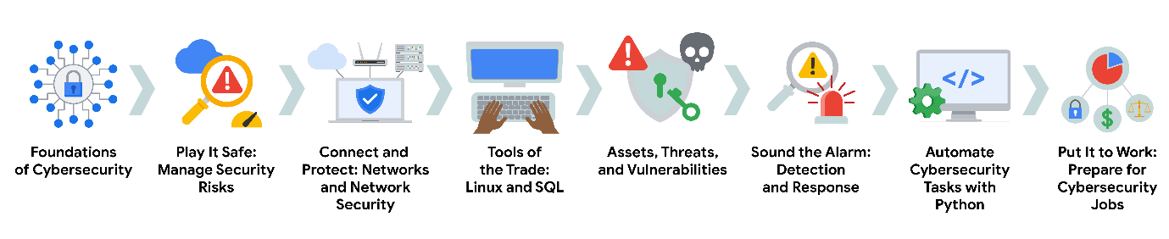

Benefits for job seekers
After completing all eight courses, Google Cybersecurity Certificate graduates have access to job search resources, courtesy of Google. You’ll have the opportunity to:
- Build your resume, participate in mock interviews, and receive job search tips through Big Interview, a job-training platform that’s free for program graduates.
- Improve your interview technique with Interview Warmup, a tool built by Google with certificate graduates in mind. Access cybersecurity-specific practice questions, transcripts of your responses, and automatic insights that help you grow your skills and confidence.
- Access thousands of job postings and free one-on-one career coaching with Career Circle. (You must be eligible to work in the U.S. to join.)
- Claim your Google Cybersecurity Certificate badge, and share your achievement on LinkedIn® professional networking services to stand out among other candidates to potential employers.
- Prepare for the CompTIA Security+ exam, the industry-leading certification for cybersecurity roles. You’ll earn a dual credential when you complete both the Google Cybersecurity Certificate and the CompTIA Security+ exam.
Congratulations on taking this first step to build your skills for a career in cybersecurity. Enjoy the journey!

Course 1 overview

Hello, and welcome to Foundations of Cybersecurity, the first course in the Google Cybersecurity Certificate. You’ve begun an exciting journey!
In this course, you will learn the primary job responsibilities and core skills of those who work in the field of cybersecurity. You will explore the eight Certified Information Systems Security Professional (CISSP) security domains, various security frameworks and controls, as well as a foundational security model called the confidentiality, integrity, and availability (CIA) triad. You will also be introduced to some common tools used by security analysts that help protect organizations and people alike.

Certificate program progress
The Google Cybersecurity Certificate program has eight courses. Foundations of Cybersecurity is the first course.
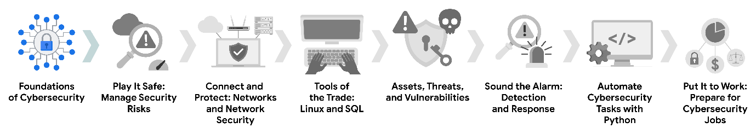
- Foundations of Cybersecurity — (current course) Explore the cybersecurity profession, including significant events that led to the development of the cybersecurity field and its continued importance to organizational operations. Learn about entry-level cybersecurity roles and responsibilities.
- Play It Safe: Manage Security Risks — Identify how cybersecurity professionals use frameworks and controls to protect business operations, and explore common cybersecurity tools.
- Connect and Protect: Networks and Network Security — Gain an understanding of network-level vulnerabilities and how to secure networks.
- Tools of the Trade: Linux and SQL — Explore foundational computing skills, including communicating with the Linux operating system through the command line and querying databases with SQL.
- Assets, Threats, and Vulnerabilities — Learn about the importance of security controls and developing a threat actor mindset to protect and defend an organization’s assets from various threats, risks, and vulnerabilities.
- Sound the Alarm: Detection and Response — Understand the incident response lifecycle and practice using tools to detect and respond to cybersecurity incidents.
- Automate Cybersecurity Tasks with Python — Explore the Python programming language and write code to automate cybersecurity tasks.
- Put It to Work: Prepare for Cybersecurity Jobs — Learn about incident classification, escalation, and ways to communicate with stakeholders. This course closes out the program with tips on how to engage with the cybersecurity community and prepare for your job search.

Course 1 content
Each course of this certificate program is broken into weeks. You can complete courses at your own pace, but the weekly breakdowns are designed to help you finish the entire Google Cybersecurity Certificate in about six months.
What’s to come? Here’s a quick overview of the skills you’ll learn in each week of this course.

Week 1: Welcome to the exciting world of cybersecurity
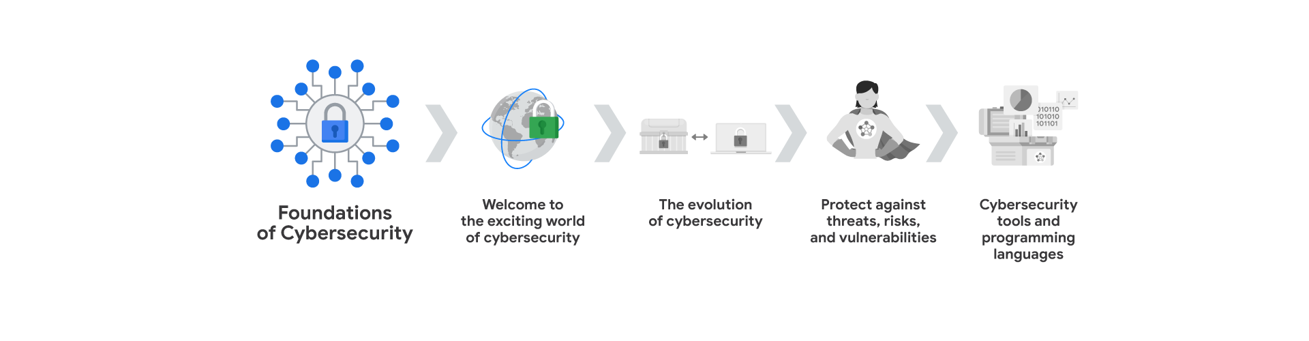
Begin your journey into cybersecurity! You'll explore the cybersecurity field, and learn about the job responsibilities of cybersecurity professionals.

Week 2: The evolution of cybersecurity
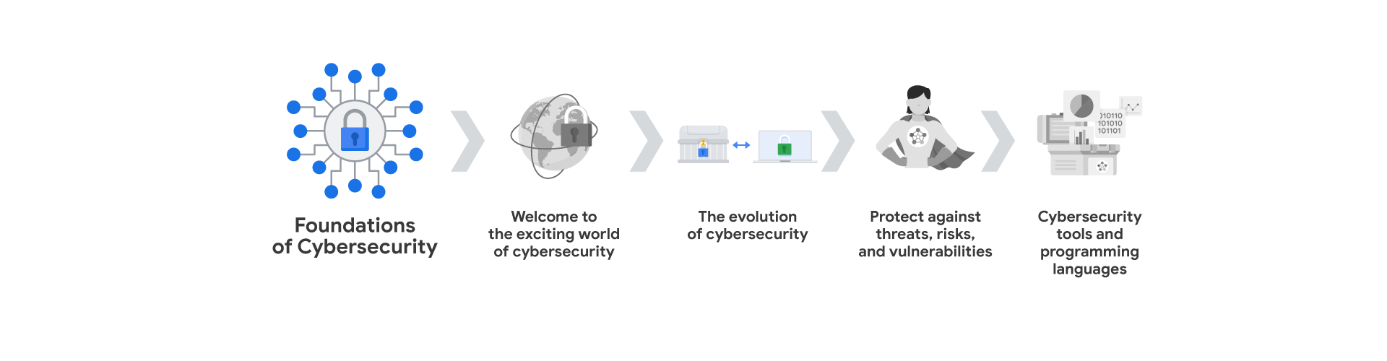
You will explore how cybersecurity threats have appeared and evolved alongside the adoption of computers. You will also understand how past and present cyber attacks have influenced the development of the security field. In addition, you'll get an overview of the eight security domains.

Week 3: Protect against threats, risks, and vulnerabilities
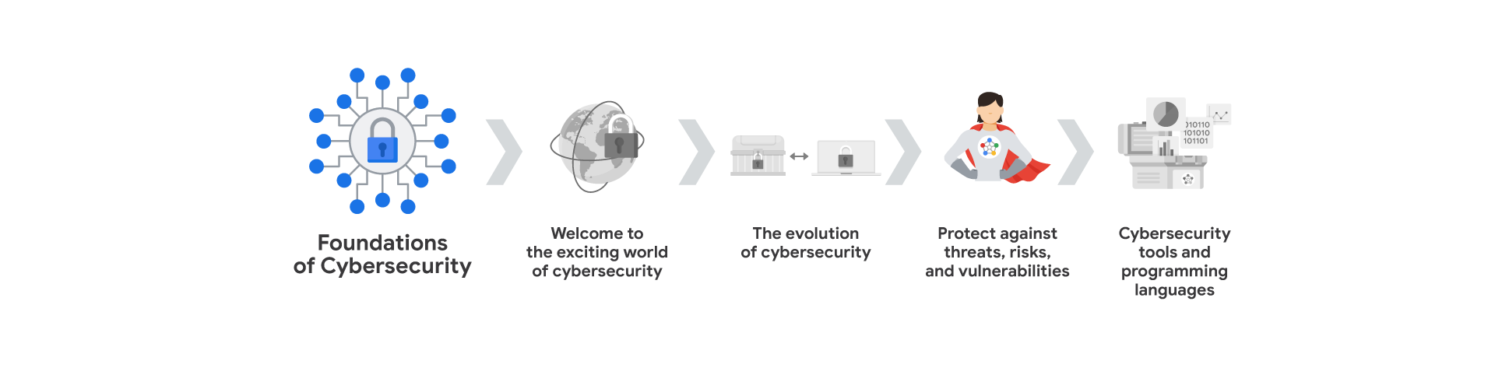
You will learn about security frameworks and controls, which are used to mitigate organizational risk. You'll cover principles of the CIA triad and various National Institute of Standards and Technology (NIST) frameworks. In addition, you'll explore security ethics.

Week 4: Cybersecurity tools and programming languages
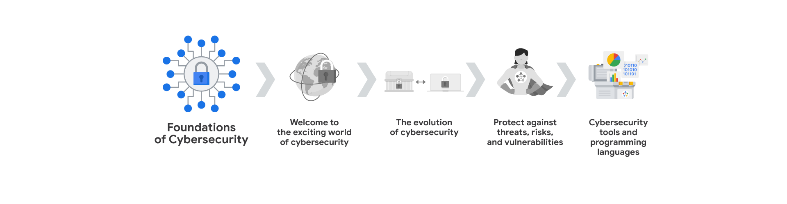
You’ll discover common tools used by cybersecurity analysts to identify and eliminate risk. You'll learn about security information and event management (SIEM) tools, network protocol analyzers, and programming languages such as Python and SQL.

What to expect
Each course offers many types of learning opportunities:
- Videos led by Google instructors teach new concepts, introduce the use of relevant tools, offer career support, and provide inspirational personal stories.
- Readings build on the topics discussed in the videos, introduce related concepts, share useful resources, and describe case studies.
- Discussion prompts explore course topics for better understanding and allow you to chat and exchange ideas with other learners in the discussion forums.
- Self-review activities and labs give you hands-on practice in applying the skills you are learning and allow you to assess your own work by comparing it to a completed example.
- Interactive plug-ins encourage you to practice specific tasks and help you integrate knowledge you have gained in the course.
- In-video quizzes help you check your comprehension as you progress through each video.
- Practice quizzes allow you to check your understanding of key concepts and provide valuable feedback.
- Graded quizzes demonstrate your understanding of the main concepts of a course. You must score 80% or higher on each graded quiz to obtain a certificate, and you can take a graded quiz multiple times to achieve a passing score.

Tips for success
- It is strongly recommended that you go through the items in each lesson in the order they appear because new information and concepts build on previous knowledge.
- Participate in all learning opportunities to gain as much knowledge and experience as possible.
- If something is confusing, don’t hesitate to replay a video, review a reading, or repeat a self-review activity.
- Use the additional resources that are referenced in this course. They are designed to support your learning. You can find all of these resources in the Resources tab.
- When you encounter useful links in this course, bookmark them so you can refer to the information later for study or review.
- Understand and follow the Coursera Code of Conduct to ensure that the learning community remains a welcoming, friendly, and supportive place for all members.

Common cybersecurity terminology
As you’ve learned, cybersecurity (also known as security) is the practice of ensuring confidentiality, integrity, and availability of information by protecting networks, devices, people, and data from unauthorized access or criminal exploitation. In this reading, you’ll be introduced to some key terms used in the cybersecurity profession. Then, you’ll be provided with a resource that’s useful for staying informed about changes to cybersecurity terminology.

Key cybersecurity terms and concepts
There are many terms and concepts that are important for security professionals to know. Being familiar with them can help you better identify the threats that can harm organizations and people alike. A security analyst or cybersecurity analyst focuses on monitoring networks for breaches. They also help develop strategies to secure an organization and research information technology (IT) security trends to remain alert and informed about potential threats. Additionally, an analyst works to prevent incidents. In order for analysts to effectively do these types of tasks, they need to develop knowledge of the following key concepts.
Compliance is the process of adhering to internal standards and external regulations and enables organizations to avoid fines and security breaches.
Security frameworks are guidelines used for building plans to help mitigate risks and threats to data and privacy.
Security controls are safeguards designed to reduce specific security risks. They are used with security frameworks to establish a strong security posture.
Security posture is an organization’s ability to manage its defense of critical assets and data and react to change. A strong security posture leads to lower risk for the organization.
A threat actor, or malicious attacker, is any person or group who presents a security risk. This risk can relate to computers, applications, networks, and data.
An internal threat can be a current or former employee, an external vendor, or a trusted partner who poses a security risk. At times, an internal threat is accidental. For example, an employee who accidentally clicks on a malicious email link would be considered an accidental threat. Other times, the internal threat actor intentionally engages in risky activities, such as unauthorized data access.
Network security is the practice of keeping an organization's network infrastructure secure from unauthorized access. This includes data, services, systems, and devices that are stored in an organization’s network.
Cloud security is the process of ensuring that assets stored in the cloud are properly configured, or set up correctly, and access to those assets is limited to authorized users. The cloud is a network made up of a collection of servers or computers that store resources and data in remote physical locations known as data centers that can be accessed via the internet. Cloud security is a growing subfield of cybersecurity that specifically focuses on the protection of data, applications, and infrastructure in the cloud.
Programming is a process that can be used to create a specific set of instructions for a computer to execute tasks. These tasks can include:
- Automation of repetitive tasks (e.g., searching a list of malicious domains)
- Reviewing web traffic
- Alerting suspicious activity

Key takeaways
Understanding key technical terms and concepts used in the security field will help prepare you for your role as a security analyst. Knowing these terms can help you identify common threats, risks, and vulnerabilities. To explore a variety of cybersecurity terms, visit the National Institute of Standards and Technology glossary. Or use your browser to search for high-quality, reliable cybersecurity glossaries from research institutes or governmental authorities. Glossaries are available in multiple languages.

Transferable and technical cybersecurity skills
Previously, you learned that cybersecurity analysts need to develop certain core skills to be successful at work. Transferable skills are skills from other areas of study or practice that can apply to different careers. Technical skills may apply to several professions, as well; however, they typically require knowledge of specific tools, procedures, and policies. In this reading, you’ll explore both transferable skills and technical skills further.

Transferable skills
You have probably developed many transferable skills through life experiences; some of those skills will help you thrive as a cybersecurity professional. These include:
- Communication: As a cybersecurity analyst, you will need to communicate and collaborate with others. Understanding others’ questions or concerns and communicating information clearly to individuals with technical and non-technical knowledge will help you mitigate security issues quickly.
- Problem-solving: One of your main tasks as a cybersecurity analyst will be to proactively identify and solve problems. You can do this by recognizing attack patterns, then determining the most efficient solution to minimize risk. Don't be afraid to take risks, and try new things. Also, understand that it's rare to find a perfect solution to a problem. You’ll likely need to compromise.
- Time management: Having a heightened sense of urgency and prioritizing tasks appropriately is essential in the cybersecurity field. So, effective time management will help you minimize potential damage and risk to critical assets and data. Additionally, it will be important to prioritize tasks and stay focused on the most urgent issue.
- Growth mindset: This is an evolving industry, so an important transferable skill is a willingness to learn. Technology moves fast, and that's a great thing! It doesn't mean you will need to learn it all, but it does mean that you’ll need to continue to learn throughout your career. Fortunately, you will be able to apply much of what you learn in this program to your ongoing professional development.
- Diverse perspectives: The only way to go far is together. By having respect for each other and encouraging diverse perspectives and mutual respect, you’ll undoubtedly find multiple and better solutions to security problems.

Technical skills
There are many technical skills that will help you be successful in the cybersecurity field. You’ll learn and practice these skills as you progress through the certificate program. Some of the tools and concepts you’ll need to use and be able to understand include:
- Programming languages: By understanding how to use programming languages, cybersecurity analysts can automate tasks that would otherwise be very time consuming. Examples of tasks that programming can be used for include searching data to identify potential threats or organizing and analyzing information to identify patterns related to security issues.
- Security information and event management (SIEM) tools: SIEM tools collect and analyze log data, or records of events such as unusual login behavior, and support analysts’ ability to monitor critical activities in an organization. This helps cybersecurity professionals identify and analyze potential security threats, risks, and vulnerabilities more efficiently.
- Intrusion detection systems (IDSs): Cybersecurity analysts use IDSs to monitor system activity and alerts for possible intrusions. It’s important to become familiar with IDSs because they’re a key tool that every organization uses to protect assets and data. For example, you might use an IDS to monitor networks for signs of malicious activity, like unauthorized access to a network.
- Threat landscape knowledge: Being aware of current trends related to threat actors, malware, or threat methodologies is vital. This knowledge allows security teams to build stronger defenses against threat actor tactics and techniques. By staying up to date on attack trends and patterns, security professionals are better able to recognize when new types of threats emerge such as a new ransomware variant.
- Incident response: Cybersecurity analysts need to be able to follow established policies and procedures to respond to incidents appropriately. For example, a security analyst might receive an alert about a possible malware attack, then follow the organization’s outlined procedures to start the incident response process. This could involve conducting an investigation to identify the root issue and establishing ways to remediate it.

CompTIA Security+
In addition to gaining skills that will help you succeed as a cybersecurity professional, the Google Cybersecurity Certificate helps prepare you for the CompTIA Security+ exam, the industry leading certification for cybersecurity roles. You’ll earn a dual credential when you complete both, which can be shared with potential employers. After completing all eight courses in the Google Cybersecurity Certificate, you will unlock a 30% discount for the CompTIA Security+ exam and additional practice materials.

Key takeaways
Understanding the benefits of core transferable and technical skills can help prepare you to successfully enter the cybersecurity workforce. Throughout this program, you’ll have multiple opportunities to develop these and other key cybersecurity analyst skills.

Glossary terms from week 1

Terms and definitions from Course 1, Week 1
Cybersecurity (or security): The practice of ensuring confidentiality, integrity, and availability of information by protecting networks, devices, people, and data from unauthorized access or criminal exploitation
Cloud security: The process of ensuring that assets stored in the cloud are properly configured and access to those assets is limited to authorized users
Internal threat: A current or former employee, external vendor, or trusted partner who poses a security risk
Network security: The practice of keeping an organization's network infrastructure secure from unauthorized access
Personally identifiable information (PII): Any information used to infer an individual’s identity
Security posture: An organization’s ability to manage its defense of critical assets and data and react to change
Sensitive personally identifiable information (SPII): A specific type of PII that falls under stricter handling guidelines
Technical skills: Skills that require knowledge of specific tools, procedures, and policies
Threat: Any circumstance or event that can negatively impact assets
Threat actor: Any person or group who presents a security risk
Transferable skills: Skills from other areas that can apply to different careers

Week-2:-

Common attacks and their effectiveness
Previously, you learned about past and present attacks that helped shape the cybersecurity industry. These included the LoveLetter attack, also called the ILOVEYOU virus, and the Morris worm. One outcome was the establishment of response teams, which are now commonly referred to as computer security incident response teams (CSIRTs). In this reading, you will learn more about common methods of attack. Becoming familiar with different attack methods, and the evolving tactics and techniques threat actors use, will help you better protect organizations and people.

Phishing
Phishing is the use of digital communications to trick people into revealing sensitive data or deploying malicious software.
Some of the most common types of phishing attacks today include:
- Business Email Compromise (BEC): A threat actor sends an email message that seems to be from a known source to make a seemingly legitimate request for information, in order to obtain a financial advantage.
- Spear phishing: A malicious email attack that targets a specific user or group of users. The email seems to originate from a trusted source.
- Whaling: A form of spear phishing. Threat actors target company executives to gain access to sensitive data.
- Vishing: The exploitation of electronic voice communication to obtain sensitive information or to impersonate a known source.
- Smishing: The use of text messages to trick users, in order to obtain sensitive information or to impersonate a known source.

Malware
Malware is software designed to harm devices or networks. There are many types of malware. The primary purpose of malware is to obtain money, or in some cases, an intelligence advantage that can be used against a person, an organization, or a territory.
Some of the most common types of malware attacks today include:
- Viruses: Malicious code written to interfere with computer operations and cause damage to data and software. A virus needs to be initiated by a user (i.e., a threat actor), who transmits the virus via a malicious attachment or file download. When someone opens the malicious attachment or download, the virus hides itself in other files in the now infected system. When the infected files are opened, it allows the virus to insert its own code to damage and/or destroy data in the system.
- Worms: Malware that can duplicate and spread itself across systems on its own. In contrast to a virus, a worm does not need to be downloaded by a user. Instead, it self-replicates and spreads from an already infected computer to other devices on the same network.
- Ransomware: A malicious attack where threat actors encrypt an organization's data and demand payment to restore access.
- Spyware: Malware that’s used to gather and sell information without consent. Spyware can be used to access devices. This allows threat actors to collect personal data, such as private emails, texts, voice and image recordings, and locations.

Social Engineering
Social engineering is a manipulation technique that exploits human error to gain private information, access, or valuables. Human error is usually a result of trusting someone without question. It’s the mission of a threat actor, acting as a social engineer, to create an environment of false trust and lies to exploit as many people as possible.
Some of the most common types of social engineering attacks today include:
- Social media phishing: A threat actor collects detailed information about their target from social media sites. Then, they initiate an attack.
- Watering hole attack: A threat actor attacks a website frequently visited by a specific group of users.
- USB baiting: A threat actor strategically leaves a malware USB stick for an employee to find and install, to unknowingly infect a network.
- Physical social engineering: A threat actor impersonates an employee, customer, or vendor to obtain unauthorized access to a physical location.

Social engineering principles
Social engineering is incredibly effective. This is because people are generally trusting and conditioned to respect authority. The number of social engineering attacks is increasing with every new social media application that allows public access to people's data. Although sharing personal data—such as your location or photos—can be convenient, it’s also a risk.
Reasons why social engineering attacks are effective include:
- Authority: Threat actors impersonate individuals with power. This is because people, in general, have been conditioned to respect and follow authority figures.
- Intimidation: Threat actors use bullying tactics. This includes persuading and intimidating victims into doing what they’re told.
- Consensus/Social proof: Because people sometimes do things that they believe many others are doing, threat actors use others’ trust to pretend they are legitimate. For example, a threat actor might try to gain access to private data by telling an employee that other people at the company have given them access to that data in the past.
- Scarcity: A tactic used to imply that goods or services are in limited supply.
- Familiarity: Threat actors establish a fake emotional connection with users that can be exploited.
- Trust: Threat actors establish an emotional relationship with users that can be exploited over time. They use this relationship to develop trust and gain personal information.
- Urgency: A threat actor persuades others to respond quickly and without questioning.

Key takeaways
In this reading, you learned about some common attacks and their impacts. You also learned about social engineering and why it’s so successful. While this is only a brief introduction to attack types, you will have many opportunities throughout the program to further develop your understanding of how to identify and defend against cybersecurity attacks.

Determine the type of attack
Previously, you learned about the eight Certified Information Systems Security Professional (CISSP) security domains. The domains can help you better understand how a security analyst's job duties can be organized into categories. Additionally, the domains can help establish an understanding of how to manage risk. In this reading, you will learn about additional methods of attack. You’ll also be able to recognize the types of risk these attacks present.

Attack types
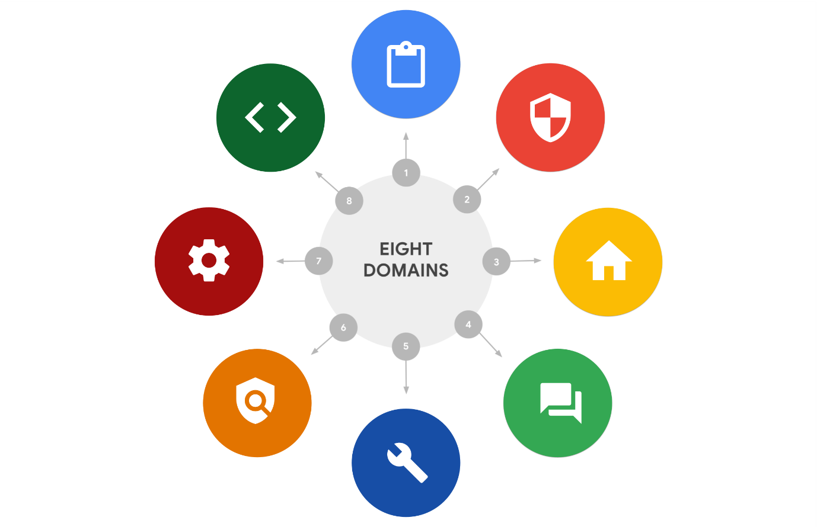

Password attack
A password attack is an attempt to access password-secured devices, systems, networks, or data. Some forms of password attacks that you’ll learn about later in the certificate program are:
- Brute force
- Rainbow table
Password attacks fall under the communication and network security domain.

Social engineering attack
Social engineering is a manipulation technique that exploits human error to gain private information, access, or valuables. Some forms of social engineering attacks that you will continue to learn about throughout the program are:
- Phishing
- Smishing
- Vishing
- Spear phishing
- Whaling
- Social media phishing
- Business Email Compromise (BEC)
- Watering hole attack
- USB (Universal Serial Bus) baiting
- Physical social engineering
Social engineering attacks are related to the security and risk management domain.

Physical attack
A physical attack is a security incident that affects not only digital but also physical environments where the incident is deployed. Some forms of physical attacks are:
- Malicious USB cable
- Malicious flash drive
- Card cloning and skimming
Physical attacks fall under the asset security domain.

Adversarial artificial intelligence
Adversarial artificial intelligence is a technique that manipulates artificial intelligence and machine learning technology to conduct attacks more efficiently. Adversarial artificial intelligence falls under both the communication and network security and the identity and access management domains.

Supply-chain attack
A supply-chain attack targets systems, applications, hardware, and/or software to locate a vulnerability where malware can be deployed. Because every item sold undergoes a process that involves third parties, this means that the security breach can occur at any point in the supply chain. These attacks are costly because they can affect multiple organizations and the individuals who work for them. Supply-chain attacks can fall under several domains, including but not limited to the security and risk management, security architecture and engineering, and security operations domains.

Cryptographic attack
A cryptographic attack affects secure forms of communication between a sender and intended recipient. Some forms of cryptographic attacks are:
- Birthday
- Collision
- Downgrade
Cryptographic attacks fall under the communication and network security domain.

Key takeaways
The eight CISSP security domains can help an organization and its security team fortify against and prepare for a data breach. Data breaches range from simple to complex and fall under one or more domains. Note that the methods of attack discussed are only a few of many. These and other types of attacks will be discussed throughout the certificate program.

Resources for more information
To view detailed information and definitions of terms covered in this reading, visit the National Institute of Standards and Technology (NIST) glossary.
Pro tip: If you cannot find a term in the NIST glossary, enter the appropriate search term (e.g., “cybersecurity birthday attack”) into your preferred search engine to locate the definition in another reliable source such as a .edu or .gov site.

Understand attackers
Previously, you were introduced to the concept of threat actors. As a reminder, a threat actor is any person or group who presents a security risk. In this reading, you’ll learn about different types of threat actors. You will also learn about their motivations, intentions, and how they’ve influenced the security industry.

Threat actor types

Advanced persistent threats
Advanced persistent threats (APTs) have significant expertise accessing an organization's network without authorization. APTs tend to research their targets (e.g., large corporations or government entities) in advance and can remain undetected for an extended period of time. Their intentions and motivations can include:
- Damaging critical infrastructure, such as the power grid and natural resources
- Gaining access to intellectual property, such as trade secrets or patents

Insider threats
Insider threats abuse their authorized access to obtain data that may harm an organization. Their intentions and motivations can include:
- Sabotage
- Corruption
- Espionage
- Unauthorized data access or leaks

Hacktivists
Hacktivists are threat actors that are driven by a political agenda. They abuse digital technology to accomplish their goals, which may include:
- Demonstrations
- Propaganda
- Social change campaigns
- Fame

Hacker types

A hacker is any person who uses computers to gain access to computer systems, networks, or data. They can be beginner or advanced technology professionals who use their skills for a variety of reasons. There are three main categories of hackers:
- Authorized hackers are also called ethical hackers. They follow a code of ethics and adhere to the law to conduct organizational risk evaluations. They are motivated to safeguard people and organizations from malicious threat actors.
- Semi-authorized hackers are considered researchers. They search for vulnerabilities but don’t take advantage of the vulnerabilities they find.
- Unauthorized hackers are also called unethical hackers. They are malicious threat actors who do not follow or respect the law. Their goal is to collect and sell confidential data for financial gain.
Note: There are multiple hacker types that fall into one or more of these three categories.
New and unskilled threat actors have various goals, including:
- To learn and enhance their hacking skills
- To seek revenge
- To exploit security weaknesses by using existing malware, programming scripts, and other tactics
Other types of hackers are not motivated by any particular agenda other than completing the job they were contracted to do. These types of hackers can be considered unethical or ethical hackers. They have been known to work on both illegal and legal tasks for pay.
There are also hackers who consider themselves vigilantes. Their main goal is to protect the world from unethical hackers.

Key takeaways
Threat actors and hackers are technically skilled individuals. Understanding their motivations and intentions will help you be better prepared to protect your organization and the people it serves from malicious attacks carried out by some of these individuals and groups.

Resources for more information
To learn more about how security teams work to keep organizations and people safe, explore the Hacking Google series of videos.

Glossary terms from week 2

Terms and definitions from Course 1, Week 2
Adversarial artificial intelligence (AI): A technique that manipulates artificial intelligence (AI) and machine learning (ML) technology to conduct attacks more efficiently
Business Email Compromise (BEC): A type of phishing attack where a threat actor impersonates a known source to obtain financial advantage
Computer virus: Malicious code written to interfere with computer operations and cause damage to data and software
Cryptographic attack: An attack that affects secure forms of communication between a sender and intended recipient
Hacker: Any person who uses computers to gain access to computer systems, networks, or data
Malware: Software designed to harm devices or networks
Password attack: An attempt to access password secured devices, systems, networks, or data
Phishing: The use of digital communications to trick people into revealing sensitive data or deploying malicious software
Physical attack: A security incident that affects not only digital but also physical environments where the incident is deployed
Physical social engineering: An attack in which a threat actor impersonates an employee, customer, or vendor to obtain unauthorized access to a physical location
Social engineering: A manipulation technique that exploits human error to gain private information, access, or valuables
Social media phishing: A type of attack where a threat actor collects detailed information about their target on social media sites before initiating the attack
Spear phishing: A malicious email attack targeting a specific user or group of users, appearing to originate from a trusted source
Supply-chain attack: An attack that targets systems, applications, hardware, and/or software to locate a vulnerability where malware can be deployed
USB baiting: An attack in which a threat actor strategically leaves a malware USB stick for an employee to find and install to unknowingly infect a network
Virus: refer to “computer virus”
Vishing: The exploitation of electronic voice communication to obtain sensitive information or to impersonate a known source
Watering hole attack: A type of attack when a threat actor compromises a website frequently visited by a specific group of users

Week-3:-

Controls, frameworks, and compliance
Previously, you were introduced to security frameworks and how they provide a structured approach to implementing a security lifecycle. As a reminder, a security lifecycle is a constantly evolving set of policies and standards. In this reading, you will learn more about how security frameworks, controls, and compliance regulations—or laws—are used together to manage security and make sure everyone does their part to minimize risk.

How controls, frameworks, and compliance are related
The confidentiality, integrity, and availability (CIA) triad is a model that helps inform how organizations consider risk when setting up systems and security policies.
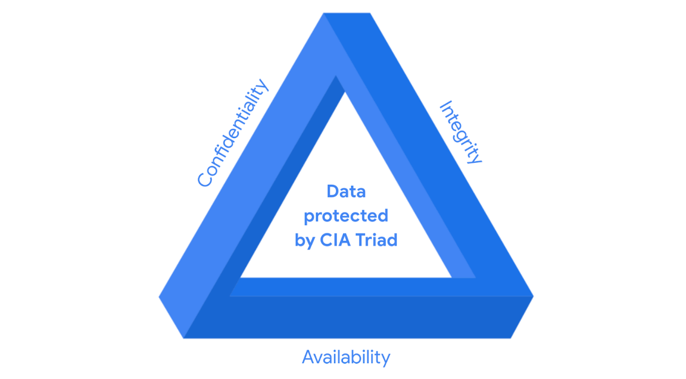
CIA are the three foundational principles used by cybersecurity professionals to establish appropriate controls that mitigate threats, risks, and vulnerabilities.
As you may recall, security controls are safeguards designed to reduce specific security risks. So they are used alongside frameworks to ensure that security goals and processes are implemented correctly and that organizations meet regulatory compliance requirements.
Security frameworks are guidelines used for building plans to help mitigate risks and threats to data and privacy. They have four core components:
- Identifying and documenting security goals
- Setting guidelines to achieve security goals
- Implementing strong security processes
- Monitoring and communicating results
Compliance is the process of adhering to internal standards and external regulations.

Specific controls, frameworks, and compliance
The National Institute of Standards and Technology (NIST) is a U.S.-based agency that develops multiple voluntary compliance frameworks that organizations worldwide can use to help manage risk. The more aligned an organization is with compliance, the lower the risk.
Examples of frameworks include the NIST Cybersecurity Framework (CSF) and the NIST Risk Management Framework (RMF).
Note: Specifications and guidelines can change depending on the type of organization you work for.
In addition to the NIST CSF and NIST RMF, there are several other controls, frameworks, and compliance standards that it is important for security professionals to be familiar with to help keep organizations and the people they serve safe.

The Federal Energy Regulatory Commission - North American Electric Reliability Corporation (FERC-NERC)
FERC-NERC is a regulation that applies to organizations that work with electricity or that are involved with the U.S. and North American power grid. These types of organizations have an obligation to prepare for, mitigate, and report any potential security incident that can negatively affect the power grid. They are also legally required to adhere to the Critical Infrastructure Protection (CIP) Reliability Standards defined by the FERC.

The Federal Risk and Authorization Management Program (FedRAMP®)
FedRAMP is a U.S. federal government program that standardizes security assessment, authorization, monitoring, and handling of cloud services and product offerings. Its purpose is to provide consistency across the government sector and third-party cloud providers.

Center for Internet Security (CIS®)
CIS is a nonprofit with multiple areas of emphasis. It provides a set of controls that can be used to safeguard systems and networks against attacks. Its purpose is to help organizations establish a better plan of defense. CIS also provides actionable controls that security professionals may follow if a security incident occurs.

General Data Protection Regulation (GDPR)
GDPR is a European Union (E.U.) general data regulation that protects the processing of E.U. residents’ data and their right to privacy in and out of E.U. territory. For example, if an organization is not being transparent about the data they are holding about an E.U. citizen and why they are holding that data, this is an infringement that can result in a fine to the organization. Additionally, if a breach occurs and an E.U. citizen’s data is compromised, they must be informed. The affected organization has 72 hours to notify the E.U. citizen about the breach.

Payment Card Industry Data Security Standard (PCI DSS)
PCI DSS is an international security standard meant to ensure that organizations storing, accepting, processing, and transmitting credit card information do so in a secure environment. The objective of this compliance standard is to reduce credit card fraud.

The Health Insurance Portability and Accountability Act (HIPAA)
HIPAA is a U.S. federal law established in 1996 to protect patients' health information. This law prohibits patient information from being shared without their consent. It is governed by three rules:
- Privacy
- Security
- Breach notification
Organizations that store patient data have a legal obligation to inform patients of a breach because if patients' Protected Health Information (PHI) is exposed, it can lead to identity theft and insurance fraud. PHI relates to the past, present, or future physical or mental health or condition of an individual, whether it’s a plan of care or payments for care. Along with understanding HIPAA as a law, security professionals also need to be familiar with the Health Information Trust Alliance (HITRUST®), which is a security framework and assurance program that helps institutions meet HIPAA compliance.

International Organization for Standardization (ISO)
ISO was created to establish international standards related to technology, manufacturing, and management across borders. It helps organizations improve their processes and procedures for staff retention, planning, waste, and services.

System and Organizations Controls (SOC type 1, SOC type 2)
The American Institute of Certified Public Accountants® (AICPA) auditing standards board developed this standard. The SOC1 and SOC2 are a series of reports that focus on an organization's user access policies at different organizational levels such as:
- Associate
- Supervisor
- Manager
- Executive
- Vendor
- Others
They are used to assess an organization’s financial compliance and levels of risk. They also cover confidentiality, privacy, integrity, availability, security, and overall data safety. Control failures in these areas can lead to fraud.
Pro tip: There are a number of regulations that are frequently revised. You are encouraged to keep up-to-date with changes and explore more frameworks, controls, and compliance. Two suggestions to research: the Gramm-Leach-Bliley Act and the Sarbanes-Oxley Act.

United States Presidential Executive Order 14028
On May 12, 2021, President Joe Biden released an executive order related to improving the nation’s cybersecurity to remediate the increase in threat actor activity. Remediation efforts are directed toward federal agencies and third parties with ties to U.S. critical infrastructure. For additional information, review the Executive Order on Improving the Nation’s Cybersecurity.

Key takeaways
In this reading you learned more about controls, frameworks, and compliance. You also learned how they work together to help organizations maintain a low level of risk.
As a security analyst, it’s important to stay up-to-date on common frameworks, controls, and compliance regulations and be aware of changes to the cybersecurity landscape to help ensure the safety of both organizations and people.

Security Ethics:-

Ethical concepts that guide cybersecurity decisions
Previously, you were introduced to the concept of security ethics. Security ethics are guidelines for making appropriate decisions as a security professional. Being ethical requires that security professionals remain unbiased and maintain the security and confidentiality of private data. Having a strong sense of ethics can help you navigate your decisions as a cybersecurity professional so you’re able to mitigate threats posed by threat actors’ constantly evolving tactics and techniques. In this reading, you’ll learn about more ethical concepts that are essential to know so you can make appropriate decisions about how to legally and ethically respond to attacks in a way that protects organizations and people alike.

Ethical concerns and laws related to counterattacks

United States standpoint on counterattacks
In the U.S., deploying a counterattack on a threat actor is illegal because of laws like the Computer Fraud and Abuse Act of 1986 and the Cybersecurity Information Sharing Act of 2015, among others. You can only defend. The act of counterattacking in the U.S. is perceived as an act of vigilantism. A vigilante is a person who is not a member of law enforcement who decides to stop a crime on their own. And because threat actors are criminals, counterattacks can lead to further escalation of the attack, which can cause even more damage and harm. Lastly, if the threat actor in question is a state-sponsored hacktivist, a counterattack can lead to serious international implications. A hacktivist is a person who uses hacking to achieve a political goal. The political goal may be to promote social change or civil disobedience.
For these reasons, the only individuals in the U.S. who are allowed to counterattack are approved employees of the federal government or military personnel.

International standpoint on counterattacks
The International Court of Justice (ICJ), which updates its guidance regularly, states that a person or group can counterattack if:
- The counterattack will only affect the party that attacked first.
- The counterattack is a direct communication asking the initial attacker to stop.
- The counterattack does not escalate the situation.
- The counterattack effects can be reversed.
Organizations typically do not counterattack because the above scenarios and parameters are hard to measure. There is a lot of uncertainty dictating what is and is not lawful, and at times negative outcomes are very difficult to control. Counterattack actions generally lead to a worse outcome, especially when you are not an experienced professional in the field.
To learn more about specific scenarios and ethical concerns from an international perspective, review updates provided in the Tallinn Manual online.

Ethical principles and methodologies
Because counterattacks are generally disapproved of or illegal, the security realm has created frameworks and controls—such as the confidentiality, integrity, and availability (CIA) triad and others discussed earlier in the program—to address issues of confidentiality, privacy protections, and laws. To better understand the relationship between these issues and the ethical obligations of cybersecurity professionals, review the following key concepts as they relate to using ethics to protect organizations and the people they serve.
Confidentiality means that only authorized users can access specific assets or data. Confidentiality as it relates to professional ethics means that there needs to be a high level of respect for privacy to safeguard private assets and data.
Privacy protection means safeguarding personal information from unauthorized use. Personally identifiable information (PII) and sensitive personally identifiable information (SPII) are types of personal data that can cause people harm if they are stolen. PII data is any information used to infer an individual's identity, like their name and phone number. SPII data is a specific type of PII that falls under stricter handling guidelines, including social security numbers and credit card numbers. To effectively safeguard PII and SPII data, security professionals hold an ethical obligation to secure private information, identify security vulnerabilities, manage organizational risks, and align security with business goals.
Laws are rules that are recognized by a community and enforced by a governing entity. As a security professional, you will have an ethical obligation to protect your organization, its internal infrastructure, and the people involved with the organization. To do this:
- You must remain unbiased and conduct your work honestly, responsibly, and with the highest respect for the law.
- Be transparent and just, and rely on evidence.
- Ensure that you are consistently invested in the work you are doing, so you can appropriately and ethically address issues that arise.
- Stay informed and strive to advance your skills, so you can contribute to the betterment of the cyber landscape.
As an example, consider the Health Insurance Portability and Accountability Act (HIPAA), which is a U.S. federal law established to protect patients' health information, also known as PHI, or protected health information. This law prohibits patient information from being shared without their consent. So, as a security professional, you might help ensure that the organization you work for adheres to both its legal and ethical obligation to inform patients of a breach if their health care data is exposed.

Key takeaways
As a future security professional, ethics will play a large role in your daily work. Understanding ethics and laws will help you make the correct choices if and when you encounter a security threat or an incident that results in a breach.

Glossary terms from module 3

Terms and definitions from Course 1, Module 3
Asset: An item perceived as having value to an organization
Availability: The idea that data is accessible to those who are authorized to access it
Compliance: The process of adhering to internal standards and external regulations
Confidentiality: The idea that only authorized users can access specific assets or data
Confidentiality, integrity, availability (CIA) triad: A model that helps inform how organizations consider risk when setting up systems and security policies
Hacktivist: A person who uses hacking to achieve a political goal
Health Insurance Portability and Accountability Act (HIPAA): A U.S. federal law established to protect patients' health information
Integrity: The idea that the data is correct, authentic, and reliable
National Institute of Standards and Technology (NIST) Cyber Security Framework (CSF): A voluntary framework that consists of standards, guidelines, and best practices to manage cybersecurity risk
Privacy protection: The act of safeguarding personal information from unauthorized use
Protected health information (PHI): Information that relates to the past, present, or future physical or mental health or condition of an individual
Security architecture: A type of security design composed of multiple components, such as tools and processes, that are used to protect an organization from risks and external threats
Security controls: Safeguards designed to reduce specific security risks
Security ethics: Guidelines for making appropriate decisions as a security professional
Security frameworks: Guidelines used for building plans to help mitigate risk and threats to data and privacy
Security governance: Practices that help support, define, and direct security efforts of an organization
Sensitive personally identifiable information (SPII): A specific type of PII that falls under stricter handling guidelines.

Week-4:-

Tools for protecting business operations
Previously, you were introduced to several technical skills that security analysts need to develop. You were also introduced to some tools entry-level security analysts may have in their toolkit. In this reading, you’ll learn more about how technical skills and tools help security analysts mitigate risks.

An entry-level analyst’s toolkit
Every organization may provide a different toolkit, depending on its security needs. As a future analyst, it’s important that you are familiar with industry standard tools and can demonstrate your ability to learn how to use similar tools in a potential workplace.

Security information and event management (SIEM) tools
A SIEM tool is an application that collects and analyzes log data to monitor critical activities in an organization. A log is a record of events that occur within an organization’s systems. Depending on the amount of data you’re working with, it could take hours or days to filter through log data on your own. SIEM tools reduce the amount of data an analyst must review by providing alerts for specific types of threats, risks, and vulnerabilities.
SIEM tools provide a series of dashboards that visually organize data into categories, allowing users to select the data they wish to analyze. Different SIEM tools have different dashboard types that display the information you have access to.
SIEM tools also come with different hosting options, including on-premise and cloud. Organizations may choose one hosting option over another based on a security team member’s expertise. For example, because a cloud-hosted version tends to be easier to set up, use, and maintain than an on-premise version, a less experienced security team may choose this option for their organization.

Network protocol analyzers (packet sniffers)
A network protocol analyzer, also known as a packet sniffer, is a tool designed to capture and analyze data traffic in a network. This means that the tool keeps a record of all the data that a computer within an organization's network encounters. Later in the program, you’ll have an opportunity to practice using some common network protocol analyzer (packet sniffer) tools.

Playbooks
A playbook is a manual that provides details about any operational action, such as how to respond to a security incident. Organizations usually have multiple playbooks documenting processes and procedures for their teams to follow. Playbooks vary from one organization to the next, but they all have a similar purpose: To guide analysts through a series of steps to complete specific security-related tasks.
For example, consider the following scenario: You are working as a security analyst for an incident response firm. You are given a case involving a small medical practice that has suffered a security breach. Your job is to help with the forensic investigation and provide evidence to a cybersecurity insurance company. They will then use your investigative findings to determine whether the medical practice will receive their insurance payout.
In this scenario, playbooks would outline the specific actions you need to take to conduct the investigation. Playbooks also help ensure that you are following proper protocols and procedures. When working on a forensic case, there are two playbooks you might follow:
- The first type of playbook you might consult is called the chain of custody playbook. Chain of custody is the process of documenting evidence possession and control during an incident lifecycle. As a security analyst involved in a forensic analysis, you will work with the computer data that was breached. You and the forensic team will also need to document who, what, where, and why you have the collected evidence. The evidence is your responsibility while it is in your possession. Evidence must be kept safe and tracked. Every time evidence is moved, it should be reported. This allows all parties involved to know exactly where the evidence is at all times.
- The second playbook your team might use is called the protecting and preserving evidence playbook. Protecting and preserving evidence is the process of properly working with fragile and volatile digital evidence. As a security analyst, understanding what fragile and volatile digital evidence is, along with why there is a procedure, is critical. As you follow this playbook, you will consult the order of volatility, which is a sequence outlining the order of data that must be preserved from first to last. It prioritizes volatile data, which is data that may be lost if the device in question powers off, regardless of the reason. While conducting an investigation, improper management of digital evidence can compromise and alter that evidence. When evidence is improperly managed during an investigation, it can no longer be used. For this reason, the first priority in any investigation is to properly preserve the data. You can preserve the data by making copies and conducting your investigation using those copies.

Key takeaways
In this reading, you learned about a few tools a security analyst may have in their toolkit, depending on where they work. You also explored two important types of playbooks: chain of custody and protecting and preserving evidence. However, these are only two procedures that occur at the beginning of a forensic investigation. If forensic investigations interest you, you are encouraged to further explore this career path or security practice. In the process, you may learn about forensic tools that you want to add to your toolkit. While all of the forensic components that make up an investigation will not be covered in this certificate program, some forensic concepts will be discussed in later courses.

Resources for more information
The Google Cybersecurity Action Team's Threat Horizon Report provides strategic intelligence for dealing with threats to cloud enterprise.
The Cybersecurity & Infrastructure Security Agency (CISA) has a list of Free Cybersecurity Services and Tools. Review the list to learn more about open-source cybersecurity tools.

Use tools to protect business operations
Previously, you were introduced to programming, operating systems, and tools commonly used by cybersecurity professionals. In this reading, you’ll learn more about programming and operating systems, as well as other tools that entry-level analysts use to help protect organizations and the people they serve.

Tools and their purposes

Programming
Programming is a process that can be used to create a specific set of instructions for a computer to execute tasks. Security analysts use programming languages, such as Python, to execute automation. Automation is the use of technology to reduce human and manual effort in performing common and repetitive tasks. Automation also helps reduce the risk of human error.
Another programming language used by analysts is called Structured Query Language (SQL). SQL is used to create, interact with, and request information from a database. A database is an organized collection of information or data. There can be millions of data points in a database. A data point is a specific piece of information.

Operating systems
An operating system is the interface between computer hardware and the user. Linux®, macOS®, and Windows are operating systems. They each offer different functionality and user experiences.
Previously, you were introduced to Linux as an open-source operating system. Open source means that the code is available to the public and allows people to make contributions to improve the software. Linux is not a programming language; however, it does involve the use of a command line within the operating system. A command is an instruction telling the computer to do something. A command-line interface is a text-based user interface that uses commands to interact with the computer. You will learn more about Linux, including the Linux kernel and GNU, in a later course.

Web vulnerability
A web vulnerability is a unique flaw in a web application that a threat actor could exploit by using malicious code or behavior, to allow unauthorized access, data theft, and malware deployment.
To stay up-to-date on the most critical risks to web applications, review the Open Web Application Security Project (OWASP) Top 10.

Antivirus software
Antivirus software is a software program used to prevent, detect, and eliminate malware and viruses. It is also called anti-malware. Depending on the type of antivirus software, it can scan the memory of a device to find patterns that indicate the presence of malware.

Intrusion detection system
An intrusion detection system (IDS) is an application that monitors system activity and alerts on possible intrusions. The system scans and analyzes network packets, which carry small amounts of data through a network. The small amount of data makes the detection process easier for an IDS to identify potential threats to sensitive data. Other occurrences an IDS might detect can include theft and unauthorized access.

Encryption
Encryption makes data unreadable and difficult to decode for an unauthorized user; its main goal is to ensure confidentiality of private data. Encryption is the process of converting data from a readable format to a cryptographically encoded format. Cryptographic encoding means converting plaintext into secure ciphertext. Plaintext is unencrypted information and secure ciphertext is the result of encryption.
Note: Encoding and encryption serve different purposes. Encoding uses a public conversion algorithm to enable systems that use different data representations to share information.

Penetration testing
Penetration testing, also called pen testing, is the act of participating in a simulated attack that helps identify vulnerabilities in systems, networks, websites, applications, and processes. It is a thorough risk assessment that can evaluate and identify external and internal threats as well as weaknesses.

Key takeaways
In this reading, you learned more about programming and operating systems. You were also introduced to several new tools and processes. Every organization selects their own set of tools. Therefore, the more tools you know, the more valuable you are to an organization. Tools help security analysts complete their tasks more efficiently and effectively.

Top 10 Web Application Security Risks
There are three new categories, four categories with naming and scoping changes, and some consolidation in the Top 10 for 2021.
- A01:2021-Broken Access Control moves up from the fifth position; 94% of applications were tested for some form of broken access control. The 34 Common Weakness Enumerations (CWEs) mapped to Broken Access Control had more occurrences in applications than any other category.
- A02:2021-Cryptographic Failures shifts up one position to #2, previously known as Sensitive Data Exposure, which was broad symptom rather than a root cause. The renewed focus here is on failures related to cryptography which often leads to sensitive data exposure or system compromise.
- A03:2021-Injection slides down to the third position. 94% of the applications were tested for some form of injection, and the 33 CWEs mapped into this category have the second most occurrences in applications. Cross-site Scripting is now part of this category in this edition.
- A04:2021-Insecure Design is a new category for 2021, with a focus on risks related to design flaws. If we genuinely want to “move left” as an industry, it calls for more use of threat modeling, secure design patterns and principles, and reference architectures.
- A05:2021-Security Misconfiguration moves up from #6 in the previous edition; 90% of applications were tested for some form of misconfiguration. With more shifts into highly configurable software, it’s not surprising to see this category move up. The former category for XML External Entities (XXE) is now part of this category.
- A06:2021-Vulnerable and Outdated Components was previously titled Using Components with Known Vulnerabilities and is #2 in the Top 10 community survey, but also had enough data to make the Top 10 via data analysis. This category moves up from #9 in 2017 and is a known issue that we struggle to test and assess risk. It is the only category not to have any Common Vulnerability and Exposures (CVEs) mapped to the included CWEs, so a default exploit and impact weights of 5.0 are factored into their scores.
- A07:2021-Identification and Authentication Failures was previously Broken Authentication and is sliding down from the second position, and now includes CWEs that are more related to identification failures. This category is still an integral part of the Top 10, but the increased availability of standardized frameworks seems to be helping.
- A08:2021-Software and Data Integrity Failures is a new category for 2021, focusing on making assumptions related to software updates, critical data, and CI/CD pipelines without verifying integrity. One of the highest weighted impacts from Common Vulnerability and Exposures/Common Vulnerability Scoring System (CVE/CVSS) data mapped to the 10 CWEs in this category. Insecure Deserialization from 2017 is now a part of this larger category.
- A09:2021-Security Logging and Monitoring Failures was previously Insufficient Logging & Monitoring and is added from the industry survey (#3), moving up from #10 previously. This category is expanded to include more types of failures, is challenging to test for, and isn’t well represented in the CVE/CVSS data. However, failures in this category can directly impact visibility, incident alerting, and forensics.
- A10:2021-Server-Side Request Forgery is added from the Top 10 community survey (#1). The data shows a relatively low incidence rate with above average testing coverage, along with above-average ratings for Exploit and Impact potential. This category represents the scenario where the security community members are telling us this is important, even though it’s not illustrated in the data at this time.

Create a cybersecurity portfolio
Throughout this certificate program, you will have multiple opportunities to develop a professional cybersecurity portfolio to showcase your security skills and knowledge.
In this reading, you’ll learn what a portfolio is and why it’s important to develop a professional cybersecurity portfolio. You’ll also learn about options for creating an online or self-hosted portfolio that you can share with potential employers when you begin to look for cybersecurity jobs.

What is a portfolio, and why is it necessary?
Cybersecurity professionals use portfolios to demonstrate their security education, skills, and knowledge. Professionals typically use portfolios when they apply for jobs to show potential employers that they are passionate about their work and can do the job they are applying for. Portfolios are more in depth than a resume, which is typically a one-to-two page summary of relevant education, work experience, and accomplishments. You will have the opportunity to develop a resume, and finalize your portfolio, in the last course of this program.

Options for creating your portfolio
There are many ways to present a portfolio, including self-hosted and online options such as:
- Documents folder
- Google Drive or Dropbox™
- Google Sites
- Git repository

Option 1: Documents folder
Description: A documents folder is a folder created and saved to your computer’s hard drive. You manage the folder, subfolders, documents, and images within it.
Document folders allow you to have direct access to your documentation. Ensuring that your professional documents, images, and other information are well organized can save you a lot of time when you’re ready to apply for jobs. For example, you may want to create a main folder titled something like “Professional documents.” Then, within your main folder, you could create subfolders with titles such as:
- Resume
- Education
- Portfolio documents
- Cybersecurity tools
- Programming
Setup: Document folders can be created in multiple ways, depending on the type of computer you are using. If you’re unsure about how to create a folder on your device, you can search the internet for instructional videos or documents related to the type of computer you use.

Option 2: Google Drive or Dropbox
Description: Google Drive and Dropbox offer similar features that allow you to store your professional documentation on a cloud platform. Both options also have file-sharing features, so you can easily share your portfolio documents with potential employers. Any additions or changes you make to a document within that folder will be updated automatically for anyone with access to your portfolio.
Similar to a documents folder, keeping your Google Drive or Dropbox-based portfolio well organized will be helpful as you begin or progress through your career.
Setup: To learn how to upload and share files on these applications, visit the Google Drive and Dropbox websites for more information.

Option 3: Google Sites
Description: Google Sites and similar website hosting options have a variety of easy-to-use features to help you present your portfolio items, including customizable layouts, responsive webpages, embedded content capabilities, and web publishing.
Responsive webpages automatically adjust their content to fit a variety of devices and screen sizes. This is helpful because potential employers can review your content using any device and your media will display just as you intend. When you’re ready, you can publish your website and receive a unique URL. You can add this link to your resume so hiring managers can easily access your work.
Setup: To learn how to create a website in Google Sites, visit the Google Sites website.

Option 4: Git repository
Description: A Git repository is a folder within a project. In this instance, the project is your portfolio, and you can use your repository to store the documents, labs, and screenshots you complete during each course of the certificate program. There are several Git repository sites you can use, including:
- GitLab
- Bitbucket™
- GitHub
Each Git repository allows you to showcase your skills and knowledge in a customizable space. To create an online project portfolio on any of the repositories listed, you need to use a version of Markdown.
Setup: To learn about how to create a GitHub account and use Markdown, follow the steps outlined in the document Get started with GitHub.

Portfolio projects
As previously mentioned, you will have multiple opportunities throughout the certificate program to develop items to include in your portfolio. These opportunities include:
- Drafting a professional statement
- Conducting a security audit
- Analyzing network structure and security
- Using Linux commands to manage file permissions
- Applying filters to SQL queries
- Identifying vulnerabilities for a small business
- Documenting incidents with an incident handler’s journal
- Importing and parsing a text file in a security-related scenario
- Creating or revising a resume
Note: Do not include any private, copyrighted, or proprietary documents in your portfolio. Also, if you use one of the sites described in this reading, keep your site set to “private” until it is finalized.

Key takeaways
Now that you’re aware of some options for creating and hosting a professional portfolio, you can consider these as you develop items for your portfolio throughout the certificate program. The more proactive you are about creating a polished portfolio, the higher your chances of impressing a potential employer and obtaining a new job opportunity in the cybersecurity profession.

Link to supporting materials: Professional statement outline

Portfolio Activity Exemplar: Draft a professional statement
Here is a completed exemplar along with an explanation of how the exemplar fulfills the expectations for the activity.

Completed Exemplar
To review the exemplar for this course item, click the following link and select Use Template.
Link to exemplar:
- Professional statement exemplar
OR
If you don’t have a Google account, you can download the exemplar directly from the following attachment.

Professional statement exemplar
DOCX File

Assessment of Exemplar
Compare the exemplar to your completed activity. Review your work using each of the criteria in the exemplar. What did you do well? Where can you improve? Use your answers to these questions to revise your project as needed and guide you as you continue to progress through the certificate program.
Note: The exemplar represents one possible way to complete the activity. Yours will likely differ in certain ways. What’s important is that your activity explains your strengths, values, and interest in the cybersecurity profession.

Glossary terms from module 4

Terms and definitions from Course 1, Module 4
Antivirus software: A software program used to prevent, detect, and eliminate malware and viruses
Database: An organized collection of information or data
Data point: A specific piece of information
Intrusion detection system (IDS): An application that monitors system activity and alerts on possible intrusions
Linux: An open-source operating system
Log: A record of events that occur within an organization’s systems
Network protocol analyzer (packet sniffer): A tool designed to capture and analyze data traffic within a network
Order of volatility: A sequence outlining the order of data that must be preserved from first to last
Programming: A process that can be used to create a specific set of instructions for a computer to execute tasks
Protecting and preserving evidence: The process of properly working with fragile and volatile digital evidence
Security information and event management (SIEM): An application that collects and analyzes log data to monitor critical activities in an organization
SQL (Structured Query Language): A programming language used to create, interact with, and request information from a database
Glossary
Cybersecurity

Terms and definitions from Course 1
A
Adversarial artificial intelligence (AI): A technique that manipulates artificial
intelligence (AI) and machine learning (ML) technology to conduct attacks more
efficiently
Antivirus software: A software program used to prevent, detect, and eliminate
malware and viruses
Asset: An item perceived as having value to an organization
Availability: The idea that data is accessible to those who are authorized to access it
B
Business Email Compromise (BEC): A type of phishing attack where a threat actor
impersonates a known source to obtain financial advantage
C
Cloud security: The process of ensuring that assets stored in the cloud are properly
configured and access to those assets is limited to authorized users
Compliance: The process of adhering to internal standards and external regulations
Computer virus: Malicious code written to interfere with computer operations and
cause damage to data and software
Confidentiality: Only authorized users can access specific assets or data

Confidentiality, integrity, availability (CIA) triad: A model that helps inform how
organizations consider risk when setting up systems and security policies
Cryptographic attack: An attack that affects secure forms of communication
between a sender and intended recipient
Cybersecurity (or security): The practice of ensuring confidentiality, integrity, and
availability of information by protecting networks, devices, people, and data from
unauthorized access or criminal exploitation

D
Database: An organized collection of information or data
Data point: A specific piece of information
H
Hacker: Any person who uses computers to gain access to computer systems,
networks, or data
Hacktivist: A person who uses hacking to achieve a political goal
Health Insurance Portability and Accountability Act (HIPAA): A U.S. federal law
established to protect patients’ health information
I
Integrity: The idea that the data is correct, authentic, and reliable
Internal threat: A current or former employee, external vendor, or trusted partner who
poses a security risk
Intrusion detection system (IDS): An application that monitors system activity and
alerts on possible intrusions
L

Linux: An open-source operating system
Log: A record of events that occur within an organization’s systems
M
Malware: Software designed to harm devices or networks
N
National Institute of Standards and Technology (NIST) Cyber Security Framework
(CSF): A voluntary framework that consists of standards, guidelines, and best
practices to manage cybersecurity risk
Network protocol analyzer (packet sniffer): A tool designed to capture and analyze
data traffic within a network
Network security: The practice of keeping an organization's network infrastructure
secure from unauthorized access
O
Open Web Application Security Project (OWASP): A non-profit organization
focused on improving software security
Order of volatility: A sequence outlining the order of data that must be preserved
from first to last
P
Password attack: An attempt to access password secured devices, systems,
networks, or data
Personally identifiable information (PII): Any information used to infer an individual’s
identity
Phishing: The use of digital communications to trick people into revealing sensitive
data or deploying malicious software

Physical attack: A security incident that affects not only digital but also physical
environments where the incident is deployed
Physical social engineering: An attack in which a threat actor impersonates an
employee, customer, or vendor to obtain unauthorized access to a physical location
Privacy protection: The act of safeguarding personal information from unauthorized
use
Programming: A process that can be used to create a specific set of instructions for a
computer to execute tasks
Protected health information (PHI): Information that relates to the past, present, or
future physical or mental health or condition of an individual
Protecting and preserving evidence: The process of properly working with fragile
and volatile digital evidence
S
Security architecture: A type of security design composed of multiple components,
such as tools and processes, that are used to protect an organization from risks and
external threats
Security controls: Safeguards designed to reduce specific security risks
Security ethics: Guidelines for making appropriate decisions as a security
professional
Security frameworks: Guidelines used for building plans to help mitigate risk and
threats to data and privacy
Security governance: Practices that help support, define, and direct security efforts
of an organization
Security information and event management (SIEM): An application that collects
and analyzes log data to monitor critical activities in an organization
Security posture: An organization’s ability to manage its defense of critical assets and
data and react to change

Sensitive personally identifiable information (SPII): A specific type of PII that falls
under stricter handling guidelines
Social engineering: A manipulation technique that exploits human error to gain
private information, access, or valuables
Social media phishing: A type of attack where a threat actor collects detailed
information about their target on social media sites before initiating the attack
Spear phishing: A malicious email attack targeting a specific user or group of users,
appearing to originate from a trusted source
SQL (Structured Query Language): A programming language used to create, interact
with, and request information from a database
Supply-chain attack: An attack that targets systems, applications, hardware, and/or
software to locate a vulnerability where malware can be deployed
T
Technical skills: Skills that require knowledge of specific tools, procedures, and
policies
Threat: Any circumstance or event that can negatively impact assets
Threat actor: Any person or group who presents a security risk
Transferable skills: Skills from other areas that can apply to different careers
U
USB baiting: An attack in which a threat actor strategically leaves a malware USB stick
for an employee to find and install to unknowingly infect a network
V
Virus: refer to “computer virus”
Vishing: The exploitation of electronic voice communication to obtain sensitive
information or to impersonate a known source

W
Watering hole attack: A type of attack when a threat actor compromises a website frequently visited by a specific group of users

